***Happy Fall!***

**November Newsletter – 2024 Season**

To Copper Valley Club Members:

The Copper Valley Club Board is looking forward to a very successful 2024 Season! Within the next few months, you will notice more announcements and information about the Copper Valley as we march into the 2024 Season.

**Recap of 2023 Season**

We would like to thank the entire 2023 members of the Copper Valley Club for a very enjoyable season! CVC had a vast number of accomplishments, and we are poised to be even more successful in 2024.

*Season Opening*

The club opened for play on April 7th. We retained Adinolfi-Raffone for the 6th consecutive year to open our clay courts. Our contract guarantees that CVC is 1st on their schedule for the Red Clay and Har-Tru court season preparations. Our Pickleball Courts also opened on the same schedule.

*In Season Highlights*

The following is a summary of highlights for the fiscal year:

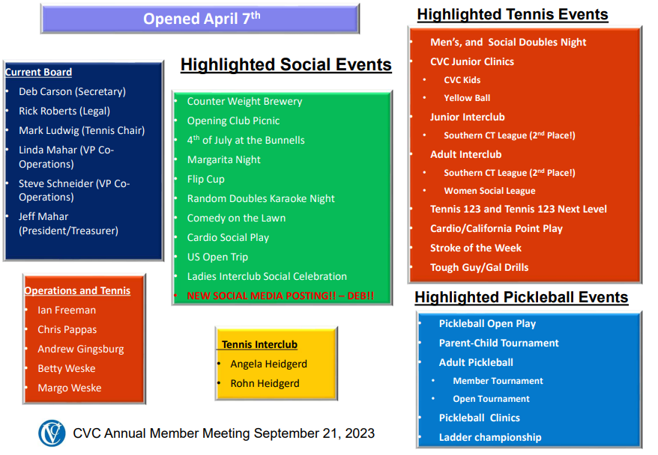

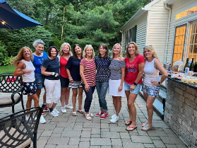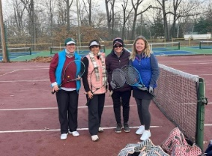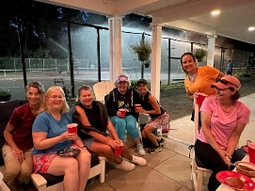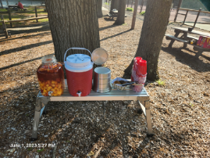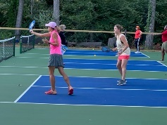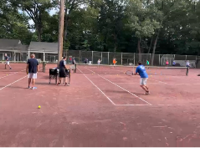

The official closing of the Har-Tru courts, three of the Red Clay courts, and the pro-shop will take place on November 11th. The remaining tennis courts 3 and 4; and all Pickleball Courts will be playable into December - **37 weeks (over 8 months) of playing tennis and pickleball outside**!

*Financial Status*

Having moved to a Tennis/Pickleball and Social only club, CVC has been able to operate **without a deficit six years in a row!** Our 2024 business plan is lined up to continue to meet this objective.

/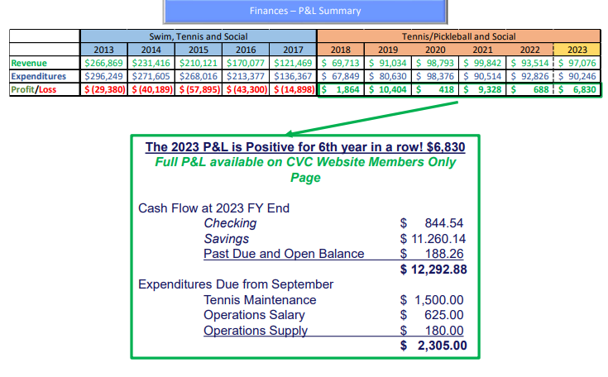

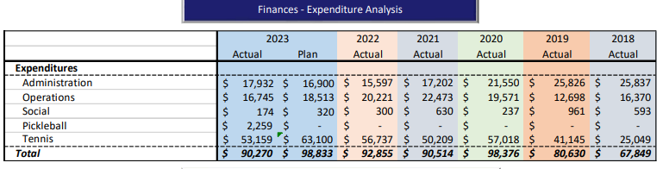

Ian Freeman, our club manager, worked tirelessly as well as number of member volunteers for the next few months to prepare the club for the full opening May 15th. Ian was instrumental in keeping the courts and grounds operational throughout the year. As you know, included in the membership to the club is a maintenance fee to help pay for the salary of our club manager. CVC did close the gap in 2023, but we were still short in self-funding the salary.



*Membership*

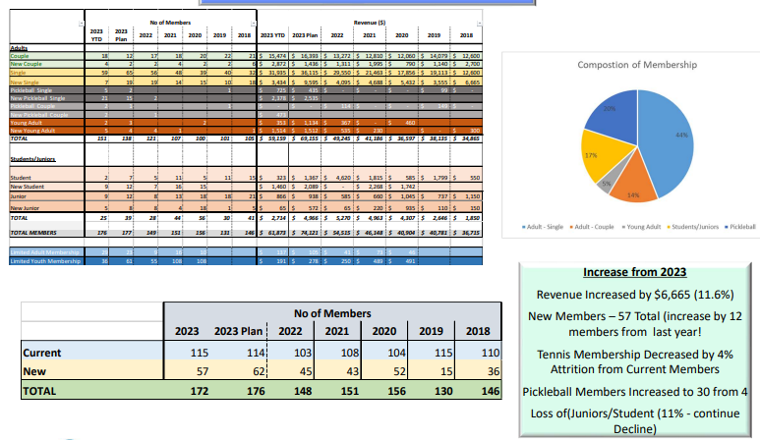

**2024 Season**

October 1st was the commencement of the new season. The CVC Board has been meeting regularly since the new board inception. The 2024 CVC Board is listening to our members! We want the club in optimum condition all year long! Our goal is to open the club the by mid-April.

The CVC Board is in the process of finalizing the business plan for 2024. For calendar year 2023, the inflation rate is estimated to finish at around 4.5%. The forecast for 2024 is in the 2-4% range. Administrative costs continue to increase year over year, and we anticipate our operational expense will return to 2022 levels anticipating better in-season weather conditions. Our maintenance salary expenditure increased 8% year over year with still a shortfall in self-funding (see discussion above)

Fiscal year 1st Q (October-December) largest expenditures are approximately: $18K

* pre-order clay material ($9.0K)
* property taxes ($5.2K)
* accounting/website expense ($0.9K)
* insurance ($0.9K)
* closing courts ($2.0K)

The CVC has decided to increase all membership fees marginally. Most of the increase is added to the maintenance fee (which does NOT have 10% Connecticut dues tax). CVC is also offering a discount to all members if full payment is received by December 15th. The fiscal year 2024 membership rates are set and can be viewed through the following link:

<http://www.coppervalleyclub.net/membership-rates-2/>.

Every member will receive an invoice reflecting their current membership status. If you wish to make any changes on the invoice just email us back.

*Board Announcements:*

The following members comprise the Board of Governors for the 2024 season:

President/Co-Treasurer – Jeffrey Mahar

Secretary/Co-Treasurer – Deb Carson

VP Administration/Operations – Linda Mahar

Tennis Committee Chair – Mark Ludwig

Pickleball Committee Chair – Andy Davis

Social Committee Chair – Open

Marketing and Social Committee Media Chair – Open

Planning Committee Chair/Legal – Rick Roberts

There are still open positions on the board and task groups. If anyone is interested, please email us at [thecoppervalleyclub@gmail.com](mailto:thecoppervalleyclub@gmail.com). Prospective board meetings will continue to set the strategic direction for the season with all minutes located on our website under the “Members Only” section. The CVC Board should have the finalized the Business Plan for the 2024 Season by the end of December.

We are looking forward to seeing everyone back at the Club in a few short months!! Stay warm, stay safe.

The CVC 2024 Board