Board Members in Attendance: [Present, Absent, Virtual]
Shawna Baron | P | John Bate | P | Paul Cahill | P | Wayne Eddy | P
Nicole Kaya | P | Marylee Kelly | P | Jeff Mahar | P | Karin Pasinski | P
Rick Roberts | P
Ian Freeman – Guest, Ashley Nolan – Guest, Rich Dubay – Guest, Tracy Ajello – Guest, Randy Light – Guest

- Meeting Start: 9:02 am
Motion to approve agenda for | 7/30 | : Moved by, 2nd by | John | , | Jeff | -approved
Motion to approve meeting minutes of | 7/9 | : Moved by 2nd by | John | , | Wayne | -approved

- Board Members
  - Board discussed/considered the immediate addition of member Rich Dubay to the CVC Board
    - Jeff motion – 2nd by John – Failed
      - Asked Rich to play a role on committee / task force until the formal club elections in October
      - After consideration Rich Dubay withdrew his board request
- Financials:
  - Reviewed current financials and 2016 vs 2017 membership numbers
    - Projecting a 6–10K fiscal year end deficit
    - See charts below and imbedded file

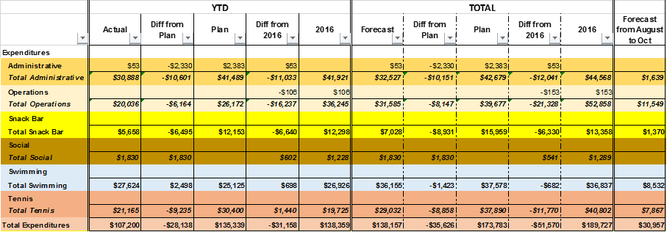

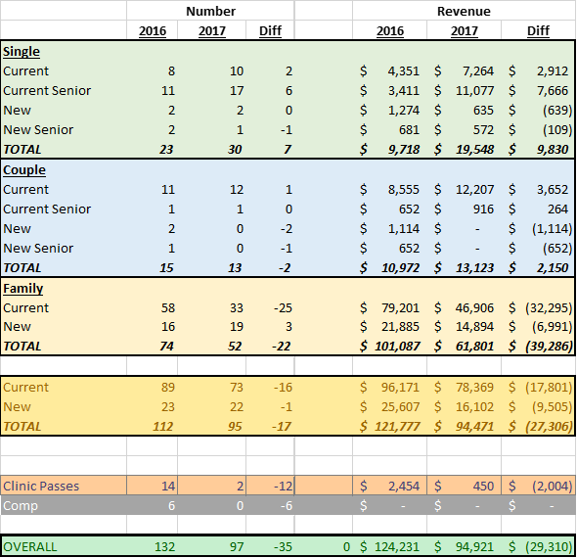

Imbedded file

  - $2500 left in STC (Short Term Capital Fund)
  - Revenue generation
    - Nicole suggested marketing the club rental option
    - Rich mentioned Mountain Grove was very successful with rental revenues
    - Comedy Night being looked at as an option
    - Task force for revenue generation formed
      - Rick, Nicole, Ashely, Jeff

- Membership/Marketing:
  - No update (see financials)

- Tennis:
  - Nish is not meeting the requirements of his contract
    - Specifically the daily hours commitment
  - Wayne is finalizing the termination of the tennis pro contract
    - Nish stays on the complete the August clinics, CAPP and cardio sessions.
      - If Nish stays to September 4th he receives 50% of Cardio, 100% of CAPP revenue and can conduct private lessons at CVC – nonmembers require guest fee to be paid by Nish
      - If Nish stays to October 6th he receives 100% of Cardio, 100% of CAPP revenue and can conduct private lessons at CVC – nonmembers require guest fee to be paid by Nish
  - Discussion about adding Cardio fees was tabled

- Pool / Swim:
  - Rich Dubay suggested more direct board involvement in the pool
  - Members commented about poor communication regarding recent pool/guard hour changes and the kiddie pool breakdown
  - Spend up to $800 on Kiddie Pool Repair
    - Nicole motion – 2nd by Karin – Passed

- Social:
  - Ashley asked about what the board did for advertising in 2016 & 2017
    - Jeff provided a list of actions taken
    - All agreed future efforts need to leverage more social media and specifically ”Intsagram”
  - Planned events
    - Intra club tennis tournament
    - Member Guest tournament
  - Social committee meeting Aug 12th

- Operations:
  - Deferred till next meeting

- Snack Bar:
  - Effective Aug 7th close snack bar during the week (keep open on weekends)
    - Jeff motion – 2nd by John – Passed
  - Change weekend snack bar hours to 12-3
    - Nicole motion – 2nd by John – Passed
  - Send notification to membership for A & B
- Full member meetings
  - Thursday, Sept 7th 6:00PM Full club meeting - Lay out where we are - options - set election slate (Date will be changed)
  - Thursday, Oct 12th 6:00PM Full Annual Meeting
- Next Meeting:
  - Wednesday 5:00 pm August 16th at CVC and Webcast

- Motion to Adjourn:
By Wayne , 2nd by Jeff – Approved | 11:55 AM
Respectfully submitted
Paul Cahill, Secretary

